CONSOLE Function

Console Function has several types. They are:

* console.log()
* console.error()
* console.warn()
* console.clear()
* console.count()
* console.table()
* console.time() and console.timeEnd
* group() and groupEnd()
* custom console log

1.**console.log():**

Mainly used to log(print) the output to the console. We can put any type inside the log(), be it a string, array, object, boolean etc.

Code:

console.log('abc');

console.log(1);

console.log(true);

console.log(null);

console.log(undefined);

console.log([1, 2, 3, 4]); // array inside log

console.log({a:1, b:2, c:3}); // object inside log

**Output with input functions:**

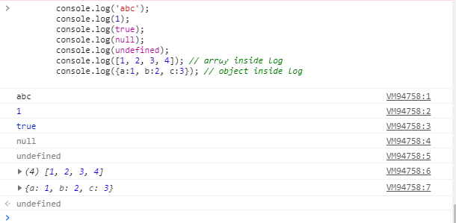

**2. console.error()**

Used to log error message to the console. Useful in testing of code. By default the error message will be highlighted with red color.

|  |
| --- |
| Code:  console.error('This is a simple error'); |

Output:

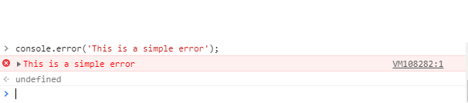

**3. console.warn()**

Used to log warning message to the console. By default the warning message will be highlighted with yellow color.

|  |
| --- |
| Code:  console.warn('This is a warning.'); |

Output:

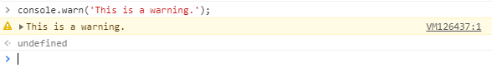

**4. console.clear()**

Used to clear the console. ‘Console was cleared’ will be the message.

|  |
| --- |
| Code:  console.clear(); |

Output:

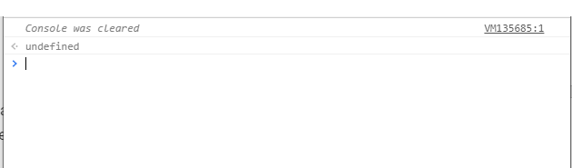

**5. console.count()**

This method is used to count the number that the function hit by this counting method.

|  |
| --- |
| Code:  for(let i=0;i<5;i++){      console.count(i); |

Output:

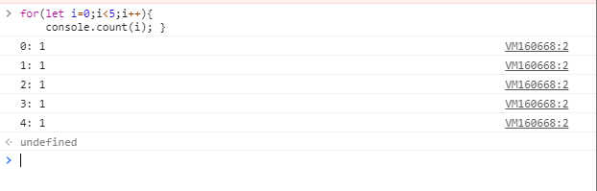

**6. console.table()**

This method allows us to generate a table inside a console. The input must be an array or an object which will be shown as a table.

|  |
| --- |
| Code:  console.table({'a':100, 'b':200}); |

Output:

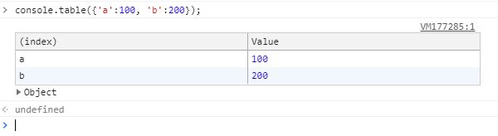

**7. console.time() and console.timeEnd()**

Whenever we want to know the amount of time spend by a block or a function, we can make use of the time() and timeEnd() methods provided by the javascript console object. They take a label which must be same, and the code inside can be anything( function, object, simple console). If we increase the amount of code inside the block defined by these methods, then the time will increase. It is also worth remembering that the time returned to the console will be in milliseconds and might be different each time we refresh the page.

|  |
| --- |
| Code:  console.time('abc');   let fun =  function()  {       console.log('fun is running');   }   let fun2 = function()  {       console.log('fun2 is running..');   }   fun();   fun2();  console.timeEnd('abc'); |

Output:

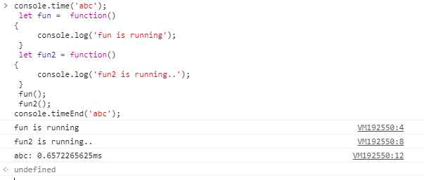

**8. console.group() and console.groupEnd()**

group() and groupEnd() methods of the console object allows us to group contents in a separate block, which will be indented. Just like the time() and the timeEnd() they also accepts label, again of same value.

Code:

console.group('simple');

  console.warn('warning!');

  console.error('error here');

  console.log('vivi vini vici');

console.groupEnd('simple');

console.log('new section');

Output:

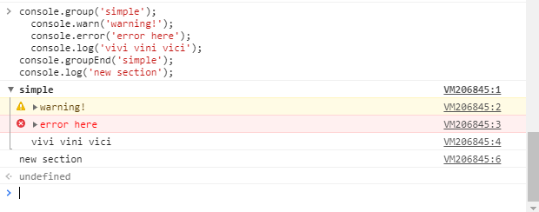

**9. custom console**

User can add Styling to the console logs in order to make logs Custom . The Syntax for it is to add the css styling as a parameter to the logs which will replace %c in the logs.

Code:

 console.log("%cThis is a green text", "color:green");

Output:

